WRITE YOUR DISSERTATION TITLE HERE (TIMES NEW ROMAN, ALL IN CAPITAL LETTERS, FONT NUMBER 14, BOLD, SINGLE SPACE)

DISSERTATION

In partial fulfilment of the requirements
for the Degree of Doctor of Philosophy
from Institut Teknologi Bandung

By
NAME OF STUDENT
Student ID: 39000001
(Doctoral Program in Management Science)



INSTITUT TEKNOLOGI BANDUNG
Month 2025

ABSTRACT

TITLE OF DISSERTATION IN ENGLISH: TYPES OF LETTER (FONT) TIMES NEW ROMAN; CAPITAL LETTER (SIZE 14); BOLD; SINGLE SPACE

By
Student Name
Student ID: 39000001
(Doctoral Program in Management Science)

Write abstract in English here. The font size is 12 and not bold. The first sentence of the abstract should be 3 spaces away from the last line of the program name. The first word or the beginning of a new paragraph should be separated by a single space from the last sentence of the preceding paragraph. Abstracts are written in English and consist of 500-800 words. The end of abstract, which is still in the sheet of this abstract but in separate line from abstract, ended with keyword (keywords). Keywords (keywords) written at the bottom of the abstract are words, which are related and derived from the abstract. IT SHOULD NOT BE derived / taken from the body/ text proposal of the dissertation. The minimum numbers of keywords are 4 single words or a single meaningful two-word combination and maximum number of keywords are 7 single words or a single meaningful two-word combination.

The proposed research contained in the abstract should comprehensively carried out the research problems, which explaining reasons why the scientific issues need to be studied; the background; the research stages; the assumptions and hypotheses that need to be proved; as well as the research objectives to be achieved; the method used; the brief review; and the explanation of the results that will be obtained in the study. The contribution of the research results to the science should be clearly stated. Abstract pages and the preparation section of the dissertation should be separately numbered from the main body page number of the dissertation. The preparatory pages are numbered by using Roman numerals i, ii, iii, iv, …, x, xi, ... to distinguish it from the main body page numbers of the proposal of dissertation in the form of Arabic numerals.

Keywords: keyword 1, keyword 2, etc.

Note:
- Footnote writing format should be removed and not allowed in the dissertation.
- The dissertation should be written on the computer on both sides of the paper page. Therefore, use the mirror margins facility available in Word Processor. Thus, the limit for the odd pages for both the left edge and top edge are 4 cm; right edge and the lower edge each 3 cm. Meanwhile for even pages, the left edge and top edge is 3 cm, whereas right edge 4 cm, and the bottom edge 3 cm.
- The term "1 space" refers to a single enter key used with the same typeface format.
- The size of paper is A4, 80 grams.

ABSTRAK

WRITE THE TITLE OF YOUR DISSERTATION IN BAHASA INDONESIA HERE (TIMES NEW ROMAN, ALL IN CAPITAL LETTER, FONT SIZE 14, BOLD, SINGLE SPACE)

Oleh
Student Name
NIM: 39000001
(Program Studi Doktor Sains Manajemen)

Write abstract in Bahasa Indonesia here. The font size is 12 and not bold. The first sentence of the abstract should be 3 spaces away from the last line of the program name. The abstract content, which is an Indonesian translation of the abstract in English language, is printed in size 1; not bold; and in italic form. The first word or the beginning of a new paragraph is separated by a single space from the last sentence of the preceding paragraph. Abstract are written in Indonesian and consist of 500-800 words. The end of abstract, which is still in the sheet of this abstract but in separate line from abstract, ended with keyword. Keywords written at the bottom the abstract are words which are related and derived from the abstract, and SHOULD NOT BE derived / taken from the body / text Dissertation. The minimum numbers of keywords are 4 single words or a single meaningful two-word combination and maximum number of keywords are 7 single words or a single meaningful two-word combination.
Abstract pages and the preparation section of the dissertation should be separately numbered from the main body page number of the dissertation. The preparatory pages are numbered by using Roman numerals i, ii, iii, iv, ..., x, xi, ... to distinguish it from the main body page numbers of the proposal of dissertation in the form of Arabic numerals.

Keywords: keyword 1, keyword 2, etc.

TITLE OF DISSERTATION: FONT TIMES NEW ROMAN; CAPITAL LETTER (SIZE 14); BOLD; SINGLE SPACE
APPROVAL

By
Name of Student
Student ID: 39000001
(Doctoral Program in Management Science)

Institut Teknologi Bandung

Approved
Promotor Team

Date ………………………..

Promotor

______________________
(Name of Promotor)

Co-Promotor I Co-Promotor II

______________________ ______________________
Name of Co-Promotor I) (Name of Co-Promotor II)

Note:
- The example of format writing of date: 2 March 2017.
- The date of approval is referred to the promotor’s approval upon the final revision.

THE GUIDANCE FOR USING THE DISSERTATION

Unpublished doctoral dissertation is registered and available in the Library of Institut Teknologi Bandung, and is open for public, provided that the author owns the copyright in accordance with the intellectual property rights that are applicable in the Library of Institut Teknologi Bandung. Bibliographical references are allowed to be use in a limited manner, however the citation and summarization can only be proceed upon the author’s permission and must include the scientific norm of stating this dissertation as the source.

This dissertation has to be cited as:
Last Name, Initial First Name. (Year): The title of dissertation that has been translated in English, Doctoral Dissertation, Institut Teknologi Bandung.

Reproduction or publication of parts or whole of the dissertation must be under the consent of the dean of The Graduate School, Institut Teknologi Bandung.

Note: The second line which is the citation continuation of the dissertation result of the first line. The initial letter starts 7 tabs (hanging indentation: 1.27 cm) from the first letter on the first line as shown in the example above.

DEDICATION PAGE

Dedication page is not a required page. If any, on the page is written for whom the dissertation is dedicated. Sentences on this page are positioned in the center of the paper.
Example:
This dissertation is dedicated to parents, husband, children, brothers and sisters, father-in-law and my beloved family who always support me.

FOREWORD

The introduction page is printed on a new page. On this page, the Doctoral students may have the opportunity to express their gratitude in writing to other mentors and or individuals who have provided guidance; advise and critics; as well as to those who have assisted in conducting the research; whether individuals or bodies that have provided financial assistance, and so forth.

In the forewords, authors may use all kinds of writing varieties. However it is advisable to keep it in a standard written sentences. Acknowledgments should be made in excessive and limited only to the "scientifically related".

Note:
Foreword is optional.

TABLE OF CONTENTS

ABSTRACT i
ABSTRAK iii
APPROVAL v
THE GUIDANCE FOR USING THE DISSERTATION vii
DEDICATION PAGE ix
FOREWORD xi
TABLE OF CONTENTS xiii
LIST OF APPENDICES xv
LIST OF FIGURES xvii
LIST OF TABLES xix
LIST OF ABREVIATIONS AND SYMBOLS xxi

Chapter I Procedure to Write Introduction 1
I.1 How to Write Background 1
I.2 How to Write References 2

Chapter II Procedure to Write Chapters in Dissertation 3

Chapter III Procedure to Write Subchapter Etc. 5
III.1 Please Write down the Title of Subchapter 5

Chapter IV Example of Formatting Title of Subchapter Which Consists of More than One Line 7
IV.1 Example of Writing Subchapter Which Consists Words of More than One Line 7
IV.1.1 Example of Numbering and Locating Title of Sub subchapter 7
IV.1.2 Example of Numbering and Locating Title of Sub subchapter 7
IV.1.3 Example of Numbering and Locating Title of Sub subchapter 7

Chapter V Conclusion 11

REFERENCES 13

APPENDICES 15

Note:
The size of letter is 12, not bold, and the line spacing is single. The table of contents contains one page or more. Table of contents is preferably be automatically formatted by the Word Processor by using the function of Style for Title, Subtitle, Heading 1, Heading 2, and so on. Afterward, it is formatted as example above.
Please refer to the outline of Dissertation as suggested by ITB Doctoral Program.
LIST OF APPENDICES

Appendix A Example of Approval Page Contains Two Promotors 17
Appendix B Example of Research Timeline 18
Appendix C Please Write the Title of the Appendix 20
C1. Please Write the Title of the Sub Appendix 20
C2. Please Write the Title of the Sub Appendix 20
Appendix D Example of Margin for Odd Pages (if the Dissertation is Printed Both Sides) 21
Appendix E Example of Margin for Even Pages (if the Dissertation is Printed on Both Sides) 22
Appendix F Example of Dissertation Cover and Binding 23

Note: The List of Appendices contains one page or more. The List of Appendices is preferably be automatically formatted by the Word Processor by using the function of Style for Reference and Subtle Reference. Henceforth, it should be formatted as the example provided above.

LIST OF FIGURES

Figure II.1 Example on how to write an image title that does not exceed one line 4
Figure III.1 Example of the title of the figure that has several parts (a) the first subfigure title, (b) the second subfigure title, and (c) the third subfigure title. 6
Figure IV.1 The relationship between dried weight straw and Cu straw wheat plant that be planted at two experimental temperature for 6 weeks. 8
Figure IV.2 The separation of two dimensions of phospholipid essence from human erythrocytes. Solvent: chloroform - methanol - light oil - water (8: 8: 6: 1) in the first dimension and acetone - chloroform - methanol - water (8: 6: 2: 2: 1) in the second dimension (Last name of author, Year). 9

Note: The List of Figures and Illustrations contains one page or more. The List of Figures and Illustrations is preferably be automatically formatted by the Word Processor by using the function of Style for Figure. Henceforth, it should be formatted as the example provided above.

LIST OF TABLES

Table III.1 The value of objective function. 6
Table III.2 The Condition of rice in North Sumatra in 3 years (1969 - 1971) (Last name of author, Year)*. 6

Note: The List of Tables contains one page or more. The List of Tables is preferably be automatically formatted by the Word Processor by using the function of Style for Table. Henceforth, it should be formatted as the provided example above.

LIST OF ABREVIATIONS AND SYMBOLS

ABREVIATIONS | Name | Page of initial usage
AMR | Adaptive Mesh Refinement
CT | Computed Tomography
DSV | Singular Value Decomposition
HPLC | High Performance Liquid Chromatography | 9
MEH | Finite Element Method
MEHA | Adaptive Finite Element Method
NMR | Nuclear Magnetic Resonance | 9
PCR | Polymerase Chain Reaction | 9
RCBM | Model-Based Image Reconstruction
Tm | Terameter
TO | Optical Tomography
TOF | Fluorescence Optical Tomography
AMR | Adaptive Mesh Refinement
SYMBOLS
A | Constant on tension relationship
A₁ | Symbol example
A_{o} | Amplitude of exit light signal
A_{i} | Amplitude of entry light signal
a | Photon on one element’s density vector
a₁ | Speed
a_{ij} | Variable reaction function in differential equation coefficient
b | Wave propagation basic equation
c | The speed of light | 5
c₀ | Specific body force
f | The probability density function | 5
I_{h} | The irradiance of scattering light
I_{m} | The irradiance of incident light
L | The radiance | 5
N | Node number
n | Light spread area’s form variable | 5
n₁ | The refractive index of the medium
n₂ | The refractive index of the object
$$\hat{n}$$ | Normal field vector against αΩ field
Q | The photon power injected per unit volume | 5
r | Position | 5
SYMBOLS | Name | Page of initial usage
$${\hat{S}}^{n-1}$$ | Light spread area | 5
$$\hat{s}$$ | Light-emitting areas | 5
t | Time | 5
α | The angle between the incident and scattered light
α₁ | First interal variable
α₂ | Second interal variable
δ | Viscosity coefficient
θ_{a} | The angle between the incident propagation direction and the normal to the interface
θ_{b} | The angle between the refracted propagation direction and the normal to the interface
λ | Wavelength
µ_{a} | The absorption coefficient | 5
$$μ_{s}$$ | The scattering coefficient
 | The domain object | 5
  Ω

Notes: Due to the nonexistence of the abbreviations and symbol in the dissertation draft templates, not all of the examples of list of abbreviation and symbol above are given the page number. Therefore, inside the Dissertation draft all abbreviations and symbols used must be written in this list. The abbreviation and symbol list pages are written on a new page. The line of words on the abbreviation list page and the symbol are spaced apart. This page contains abbreviations of terms, units and symbols of variables / numbers (written in the first column), variable names and full name names written on the back of the emblem and abbreviation (written in the second column), and the page number where the symbolic abbreviation appears for the first time written in the third column).

The abbreviations and symbols in the first column are sorted in Latin alphabet. Capital letters followed by their lowercase letters and then followed by symbols written in Greek letters that are also sorted according to the Greek alphabet. The variable name/ quantity or the name of the term in the second column is written in lowercase; except the first letter, which should be written in capital letters.

Chapter I Procedure to Write Introduction

Write the opening paragraph here (if any). The chapter title of the introduction (size 14, bold), written in lowercase except the first letter, is printed parallel to Chapter I without the full stop at the end of the last letter and placed symmetrically (centered) on the page. The main body of the proposed research consists of the introduction, which is the first chapter; the literature review, which is the chapter of the main content chapter of the dissertation; including the research schedule as well as the novelty and originality. The introductory chapter contains at least (details in sub chapters) the following:
- Background and descriptions of the problem;
- Purposes, objectives, scopes, and limitations of the problem;
- Statement of problem and research questions;
- Research approach and methods used;
- Assumptions;
- Hypotheses;
- Novelty and originality.

I.1 How to Write Background
The paragraphs on the dissertation do not contain indentations. Therefore, the first letter of the new paragraph starts from the left margin of the script. Put a blank line of 1.5 spaces and 12-letter size to separate the first line of the new paragraph from the last line of the preceding paragraph.

Do not start a new paragraph on the bottom of the page unless there is enough space for at least two lines. The last line of a paragraph should not be placed on the next new page. Leave the last line at the bottom of the current page. Otherwise, you should have to edit the paragraph to fit in the same page. Paragraph should contains one main idea / thought that composed of several sentences. Therefore, avoid paragraph that consists only one sentence.

I.2 How to Write References
For more than two writers / authors, the first author's name is written, followed by et al., then the year of publication. For example "Kramer et al. (2005) states that hominid tooth fossils have been found by his team in Ciamis. They are the first hominid fossils found in West Java". Moreover, it is acceptable to paraphrase sentences as it can also be written first followed by the citations (Name of Author, Year).

All references listed must be properly referred in the dissertation text, vice versa. The use of footnotes to indicate referrals is strongly discouraged as it has to be described in the dissertation text.

How to write references on sentences that are adapted, are as follows
References written by 1 person: "(Hill, 2007)"
References written by more than two people, accompanied by the referenced page number of the book: "(Baker et al., 1998: 23-25)"
1 reference written by two people: "(Gao and Zhao, 2009)"
2 references with different number of authors: "(Hill, 2007 and Krammer et al., 2005)"
2 references that are written by more than 2 persons: "(Kramer et al, 2005 and Kumai et al., 1985)"
2 references that are written by the same main author, but published at different times: "(Culver et al., 2003a and 2003b)"
More than 2 references: "(Hill, 2007; Kramer et al., 2005; Gao and Zhao, 2009)"
How to write references in the sentence: ".... research results of Wijaya (1996)”
Chapter II Procedure to Write Chapters in Dissertation

Each new chapter should start with an odd numbered page. Use the “Page Break” facility in Microsoft word to add a blank page if the last paragraph of a chapter is on the odd page.

The literature review chapter covers the flow of thought and scientific development in the topic of study. Essentially, the research results of a researcher is not a new discovery that stands alone but something that is related to the results of previous researches. The literature review should be elaborating the results of previous researchers with the problems studied by doctorate students in such way that provides an overview of the development of knowledge underlying the writing of dissertations. The literature review shows the expertise of doctorate students in the fundamental science related to the issues reviewed. Therefore, the literature review is NOT a description of common methods and / or basic theoretical that will be used.

The literature review should be arranged in accordance with the order of the development of the knowledge. The literature review also contains reviews of the references and demonstrates why and how the student chooses the topic of study. The literature review can be inserted into the contents of the chapter (in accordance with the requirements of writing and principle in each discipline of science) and should not be written in separate chapter.



Figure II.1 Example on how to write an image title that does not exceed one line

If the title of the figure consists of one line, it should be placed symmetrically (centered) according to the margin of paper that can be printed. If the title of the figure consists of two or more lines, it should be aligned as justifies text. In this case, the second line of the title and so forth is a continuation of the first line. The initial letter writing begins under the first letter on the first line of the title of the figure (use the hanging paragraph facility available in Word Processor). Example of formatting the title of the figure consists of one line is shown in Figure II.1".

Attachments can be tables, figures, etc. which are (considered) as not the main body of the Dissertation. The Appendix MUST BE referred in the dissertation text with the format: "Appendix A". The examples of how to refer the appendices are as followed: Appendix A, Appendix B, Appendix C, Appendix D, Appendix E, and Appendix F.

Chapter III Procedure to Write Subchapter Etc.

III.1 Please Write down the Title of Subchapter
The title of the chapter can be directly followed by the title of the subchapter. It is not allowed to sequentially write title of the chapter, title of subchapter, and title of sub subchapter. Insert at least 1 (one) paragraph between the title of the chapter and the title of the sub chapter or between title of the sub chapter and title of the sub subchapter.

Example of writing a long equation, the cuts will be done on the sign of arithmetic operation or equal sign. It does not need all the equations to be numbered. The equation number is placed in the lower right corner as follows:
$$\frac{1}{c}\frac{∂L\left(r,\hat{s},t\right)}{∂t}+\hat{s}⋅∇L\left(r,\hat{s},t\right)+\left(μ_{a}+μ_{s}\right)L\left(r,\hat{s},t\right)=$$
$$μ_{s}\oint_{{\hat{S}}^{n-1}}{L\left(r,\hat{s}',t\right)f\left(\hat{s},\hat{s}'\right)}d{\hat{s}}^{'}+Q\left(r,\hat{s},t\right) , r ϵ Ω⊂R^{n},\hat{s} ϵ {\hat{S}}^{n-1}$$ | (III.1)
in which:
c = the speed of light
r = position
and so on.

Write a new paragraph here by adding 1 line space. Each new paragraph should consist of several sentences. The explanation of the symbol used in the equation can be written in the form of sentence e.g. the radiance is represented by the symbol L, ŝ is the vector of light travel and so on or in bullet points.

Examples of short writing are as follows:
$L\left(r_{b},\hat{s},t\right) =L_{o}\left(r_{b},\hat{s},t\right), \left(r_{b},\hat{s}\right)ϵ∂Ω×{\hat{S}}^{n-1},jika \hat{s}∙ \hat{n}<0$ | (III.2)
the continuation sentence, which is not a new paragraph, should be written without adding line space between the equations and the continuation sentence.

Each figure in the dissertation text is numbered and should be referred to the body text of the dissertation. Figure III.1 shows examples of the formatting the title of the figure with a description of components a, b, and c in the figure.

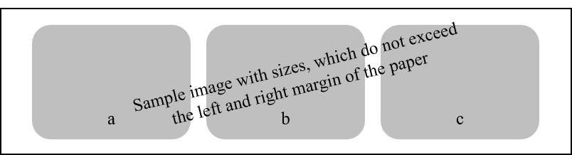

Figure III.1 Example of the title of the figure that has several parts (a) the first subfigure title, (b) the second subfigure title, and (c) the third subfigure title.

Examples of short table title and figure format are shown in Table III.1:

Table III.1 The value of objective function.

Object | Objective Function
1 | 2.44x10⁻⁶
2 | 2.90x10⁻⁴
3 | 2.87x10⁻⁵

Table III.2 The Condition of rice in North Sumatra in 3 years (1969 - 1971) (Last name of author, Year)*.

Year | Rice production  (Tonnes) | Rice Consumptionª  (Tonnes) | Import of Rice^{b}  (Tonnes)
1969  1970  1971 | 676.60  691.65  755.56 | 731.75  748.87  789.10 | 70.60  40.51  46.27
- People Agriculture Office, North Sumatera Province.
- Export-import realization and list of export of goods development of North Sumatra, the North Sumatra Province Ministry of Trade representatives, page 14.

* Note: if the table is quoted from a paper or book then it is necessary to write the name of the author / writer, agency, or other sources.
Chapter IV Example of Formatting Title of Subchapter Which Consists of More than One Line

The title of the chapter cannot be directly followed by the title of the subchapter; there must at least a paragraph explaining the whole chapter (you have to insert the sentence between the title of the chapter and the title of subchapter). Insert at least 1 (one) paragraph between the title of the chapter and the title of the sub chapter.

IV.1 Example of Writing Subchapter Which Consists Words of More than One Line
Examples of title of chapters and subchapters that consist of more than one line are shown in the chapter titles IV and chapter IV.1. The last line of the title of the chapter shall not be directly followed by the title of sub chapter (without inserting the sentence between the title of chapter and the title of sub chapter). Moreover it is not allowed to sequentially write the title of chapter, the title of sub chapter, and the title of sub subchapter without inserting the sentence between those three. Insert at least 1 (one) paragraph between title of the sub chapter and title of the sub subchapter.

IV.1.1 Example of Numbering and Locating Title of Sub subchapter
Write new paragraph here after inserting 1 line space. Each new paragraph should consist of several sentences.

IV.1.2 Example of Numbering and Locating Title of Sub subchapter
Tulislah paragraf baru disini dengan terlebih dahulu memberi 1 spasi. Setiap paragraf baru sebaiknya terdiri atas beberapa kalimat.

IV.1.3 Example of Numbering and Locating Title of Sub subchapter
Write new paragraph here after inserting 1 line space. Each new paragraph should consist of several sentences.
Figure IV.1 shows an example of formatting the title of a graph, which is still expressed as a figure. This is due to the dissertation guide book which is stated that the term figure includes figures; illustrations; graphs; diagrams; floor plans; maps; charts; monograms; flow charts; and portraits. The figure should be printed on the paper used for the script (dissertation). Original figure should be made with printer or plotter or similar quality printers. The letters, numbers, and other punctuation marks used in the figure should be clear. Meanwhile, Figure IV.2 shows examples of reference in writing on the figure quoted from papers or books, so the name of the writer / author, agency, or other sources needs to be cited.

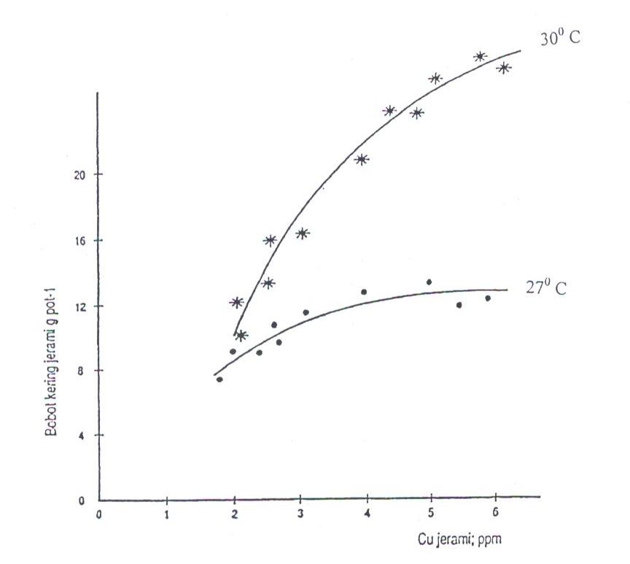

Figure IV.1 The relationship between dried weight straw and Cu straw wheat plant that be planted at two experimental temperature for 6 weeks.

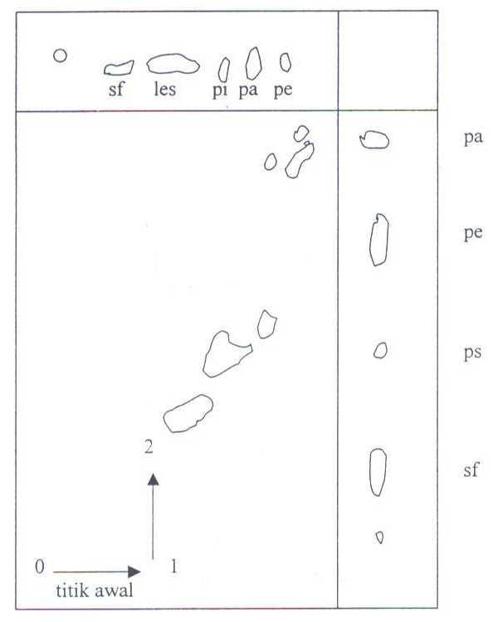

Figure IV.2 The separation of two dimensions of phospholipid essence from human erythrocytes. Solvent: chloroform - methanol - light oil - water (8: 8: 6: 1) in the first dimension and acetone - chloroform - methanol - water (8: 6: 2: 2: 1) in the second dimension (Last name of author, Year).

These are examples of abbreviations writing in dissertation. These are some of abbreviations that included in the abbreviations and symbols list e.g. High Performance Liquid Chromatography (HPLC), Nuclear Magnetic Resonance (NMR), and Polymerase Chain Reaction (PCR).

Chapter V Conclusion

This chapter contains elaborations and details of conclusions written on the abstract. Suggestions for further study and practical implication of Doctoral student work can be written in this chapter.
REFERENCES

Baker, A. A., Sosro, K., and Suditomo, B. (1998): Pembakaran hutan di Kalimantan, Majalah Kehutanan, 5, 23 – 25.
Cotton, F. A. (1998): Kinetics of gasification of brown coal, Journal of American Chemical Society, 54, 38 – 43.
Culver, J.P., Durduran, T., Furuya, D., Cheung, C., Greenberg, J.H., and Yodh, A.G. (2003a): Diffuse optical tomography of cerebral blood flow, oxygenation, and metabolism in rat during focal ischemia, Journal of Cerebral Blood Flow & Metabolism, 23, 911 – 924.
Culver, J.P., Siegel, A.M., Stott, J.J., and Boas, D.A. (2003b): Volumetric diffuse optical tomography of brain activity, Optics Letters, 28, 2061 – 2063.
Gao, H. and Zhao, H. (2009): A fast forward solver of radiative transfer equation, Transport Theory and Statistical Physics, 38, 149 – 192.
Guven, M., Yazici, B., Giladi, E., and Intes, X. (2007): Adaptive mesh generation for diffuse optical tomography, 4th IEEE International Symposium on Biomedical Imaging: From Nano to Macro, 1380 - 1383.
Hill, R. (1997): The mathematical theory of plasticity, Oxford Press, Oxford, 545 – 547.
Kramer, A., Djubiantono, T., Aziz, F., Bogard, J. S., Weeks, R. A., Weinand, D. C., Hames, W. E., Elam, J. M., Durband, A. C., and Agus (2005): The first hominid fossil recovered from West Java, Indonesia, Journal of Human Evolution, 48, 661 – 667.
Kumai, H., Itihara, M., Sudijono, Shibasaki, T., Aziz, F., Yoshikawa, S., Akahane, S., Soeradi, T., Hayashi, T., and Furuyama, K. (1985): Geology and stratigraphy of the Mojokerto Area, 55 – 61 dalam N. Watanabe and D. Kadar, ed., Quaternary geology of the hominid fossil bearing formations in Java, 378 page., Geological Research and Development Centre, Bandung-Indonesia.
Stark, H. (1998): The dynamics of surface adsorption, Proceedings of the International Congress on Current Aspects of Quantum Chemistry, London, U.K., Carbo R., ed., Prentice Hall, 24 – 36.
Wijaya, R. (1996): Diagnosis penyakit tipus dengan metode PCR, Disertasi Program Doktor, Institut Teknologi Bandung, 25 – 29.

References from Newspaper:
Article title. (Date). Newspaper Name, page. XX.
Informant (Date). Article title. Newspaper Name, page.YY.
Pengelolaan diusulkan satu lembaga. (16 Oktober 2015). Kompas, page. 14.
Saidi, A. I. (16 Oktober 2015). Semiotika laut. Kompas, page. 6.

References from Film or Television:
Figure Name (The Position of the Figure). (Date). Event Name [event Type]. Television Station Name/Film Producer: City.
Sagantoro, A. (Produser). (2011). The Raid [Gambar Hidup]. PT. Merantau Films and XYZ Films: Jakarta.
Arlusi, R. and Ginting E. (Executive Producer). (21 Oktober 2015). Mata Najwa [Television Broadcast]. Metro TV: Jakarta.

References from website:
Data Air Mampu Curah periode 1950 – 2000 is a grid data (reanalysis) from National Centre for Environmental Prediction (NCEP), data is obtained from website: http://www.esrl.noaa.gov/psd/data/gridded/data.ncep. reanalys2.html. Downloaded on 5 May 2013.
Data Indeks DM periode 1901 – 2000 the result of reanalysis from Japan Agency for Marine Earth Science and Technology (JAMSTEC), data is obtained from website: http:/www.jamstec.go.jp/frcgc/research/d1/iod/ kaplan_sst_dmi _new.txt. Downloaded on 28 October 2013.
Peta Pola Suhu Permukaan Laut (SPL) di Samudra India Ekuatorial, data is obtained from website: http://www.jamstec.go.jp/frsgc/research/d1/iod/. Downloaded on 2 Agust 2012.

Note:
- Types of references writing formats are as follow:
First reference is magazine written by more than 2 authors.
Second reference is journal written by single author.
Third and fourth references are references written by the same main author but published at different time.
Fifth reference is reference written by 2 authors.
Sixth reference is pustaka yang dipublikasikan melalui konferensi.
Seventh reference is book.
Eighth reference is journal written by more than 2 authors.
Ninth reference is book that each chapter written by different authors and there is editor/s.
Tenth reference is proceeding prosiding.
Eleventh reference is doctoral program dissertation.
- Additional criteria regarding appropriateness for inclusion in the references follows the prevalence in each discipline of science and is governed by the KPPs-Faculties.
- It is not allowed to cite from newspaper, radio or TV unless it is used as research object. The references form website is also written in alphabetically order, not necessarily numbered.
- If any master program thesis used as reference, the format is as shown by the eleventh reference.

APPENDICES

Appendix A Example of Approval Page Contains Two Promotors

DISSERTATION TITLE FONT: TIMES NEW ROMAN; CAPITAL LETTER: 14; BOLD; SINGLE SPACE

By
Student Name
Student ID: 3500001
(Doctoral Program in Management Science)

Institut Teknologi Bandung

Approved
Promotor Team

Date ...............................

Promotor Co-Promotor

______________________ ______________________
(Name of Promotor) (Name of Co-Promotor)

Appendix B Example of Research Timeline

No | Year/month | YEAR I |  |  |  |  |  |  |  |  |  |  |  | YEAR II |  |  |  |  |  |  |  |  |  |  |  | YEAR III
No | Activities | 1 | 2 | 3 | 4 | 5 | 6 | 1 | 2 | 3 | 4 | 5 | 6 | 1 | 2 | 3 | 4 | 5 | 6 | 1 | 2 | 3 | 4 | 5 | 6 | 1 | 2 | 3 | 4 | 5 | 6 | 1 | 2 | 3 | 4 | 5
1 | Literature Review
2 | Qualification Examination
3 | Writing Research Proposal
4 | Preparation and seeking for Field Research
5*) | Field Research
6**) | Laboratory Analysis  Method 1
7**) | Laboratory Analysis  Method 2
8**) | Laboratory Analysis  Method 3
9 | Synthesis
10 | Publication
11 | Studio Work

Appendix B Example of Research Timeline (continued)

No | Year/month | YEAR I |  |  |  |  |  |  |  |  |  |  |  | YEAR II |  |  |  |  |  |  |  |  |  |  |  | YEAR III
No | Activities | 1 | 2 | 3 | 4 | 5 | 6 | 1 | 2 | 3 | 4 | 5 | 6 | 1 | 2 | 3 | 4 | 5 | 6 | 1 | 2 | 3 | 4 | 5 | 6 | 1 | 2 |  | 3 | 4 | 5 |  | 6 | 1 | 2 | 3 | 4 | 5
12 | Progress Seminar 1/2/3/4 |  |  |  |  |  |  |  |  |  |  |  |  |  |  |  |  |  |  | 1 |  |  |  | 2 |  |  |  | 3 |  |  |  |  |  | 4
13 | International Journal: accepted
14 | Writing Dissertation Draft
15 | Closed Examination
16 | Doctoral Promotion Defence

Note: *) = If there any field activities; **) = If there any laboratory analysis using various methods
Appendix C Please Write the Title of the Appendix

C1. Please Write the Title of the Sub Appendix
Write a new paragraph here by adding 1 line single space. Each new paragraph should consist of several sentences.

C2. Please Write the Title of the Sub Appendix
Write a new paragraph here by adding 1 line single space. Each new paragraph should consist of several sentences.

Note: The Appendix may consist of several pieces. The appendix may contain additional notes; formula derivation; calculation examples; raw research data; etc., which, if incorporated into the body of the dissertation will interfere the explanation smoothness in the body of the dissertation. Each appendix is numbered in the capital letters of the Latin alphabets A, B, C, ... and so on. The appendix is preceded by a page containing only the word APPENDICES (size 14, bold) in the middle of the page and given the page number. The appendix can be tables, figures, and so on which (is considered) not a major part of the dissertation. The appendix MUST be referred in the dissertation body with the format e.g. "Appendix A".

Appendix D Example of Margin for Odd Pages (if the Dissertation Document is Printed Both Sides)

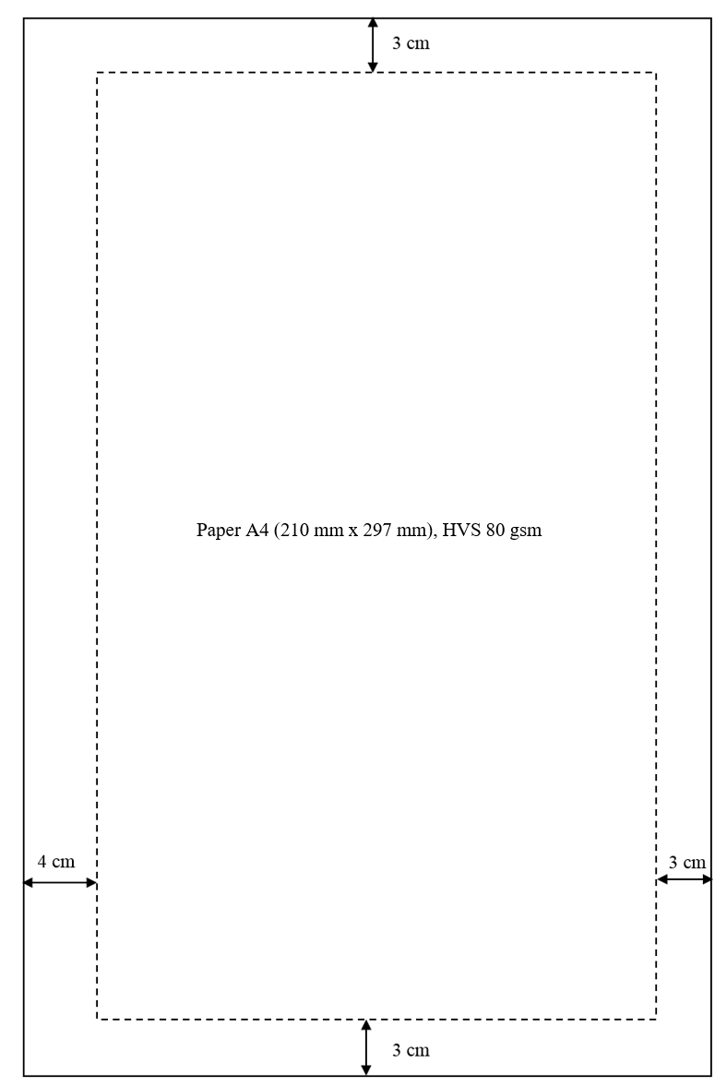
Note: The above illustration is not an actual measure. Author can use thicker paper if needed, for example: if a printout looms into the back of the paper.
Appendix E Example of Margin for Even Pages (if the Dissertation Document is Printed on Both Sides)

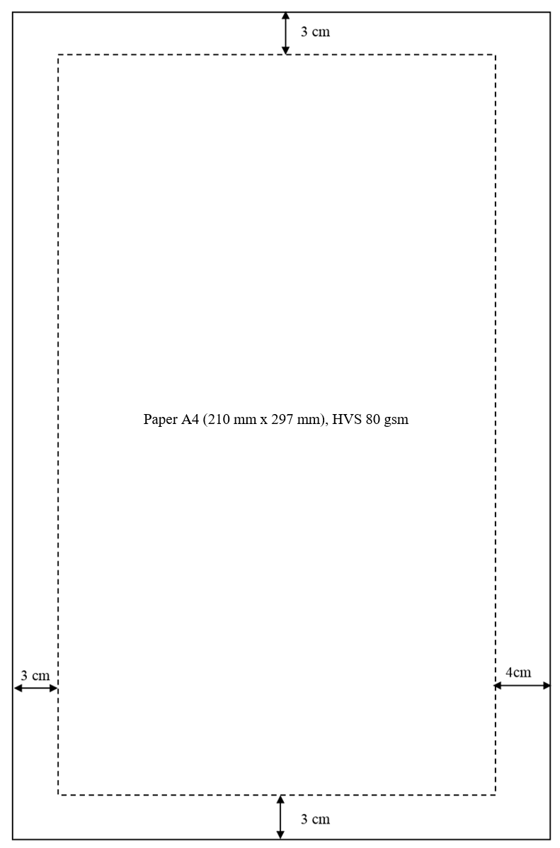
Note: The above illustration is not an actual measure.

Appendix F Example of Dissertation Cover and Binding
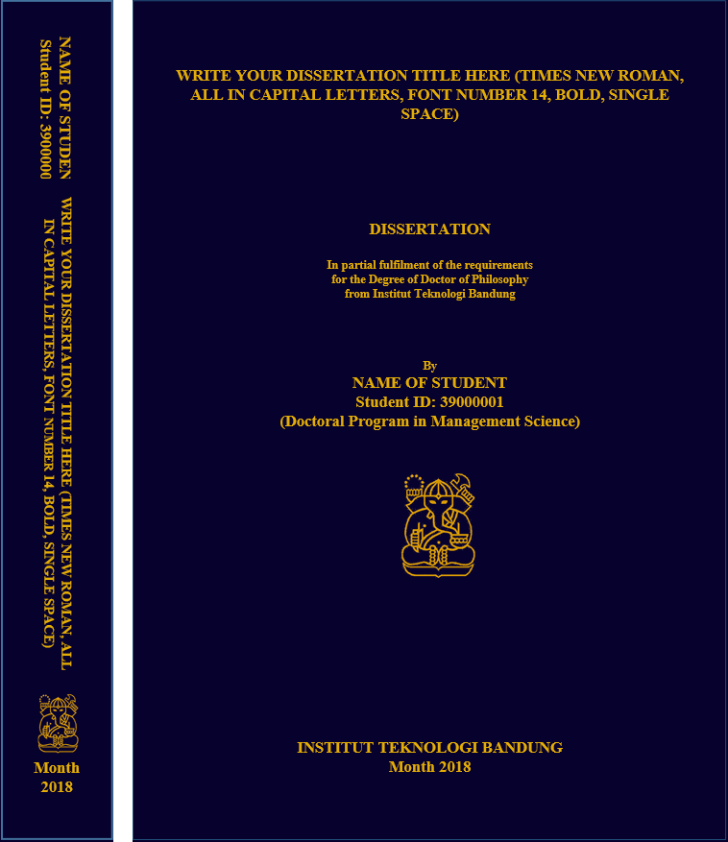

Note: The dissertation document should be bound by a hard cover, with a binding technique. Dark Blue, paper type: Omega No. 10 and the text should be printed in gold ink.

